# CS 255 System Design Document Aaron McDonald.

## UML Diagrams

### UML Use Case Diagram

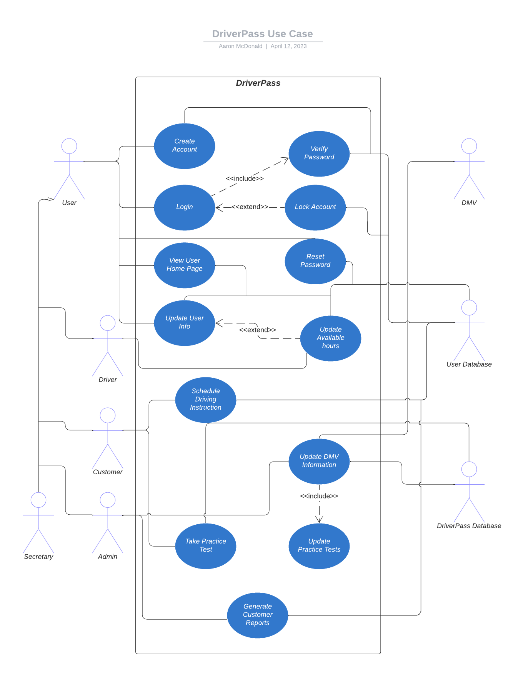

### UML Activity Diagrams

### 

### UML Sequence Diagram

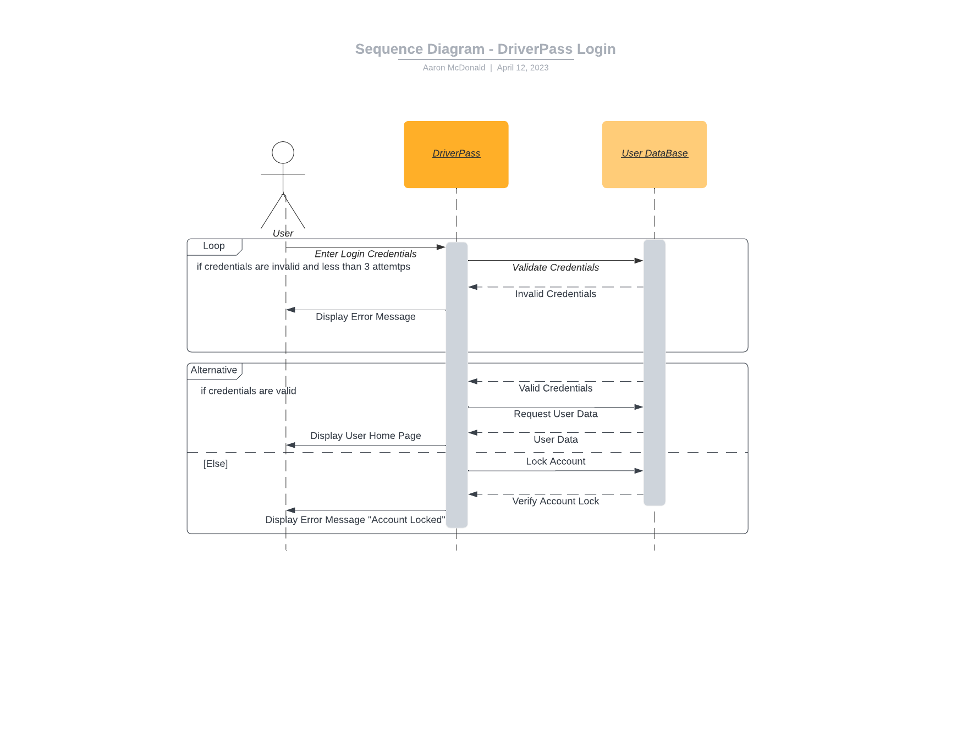

### UML Class Diagram

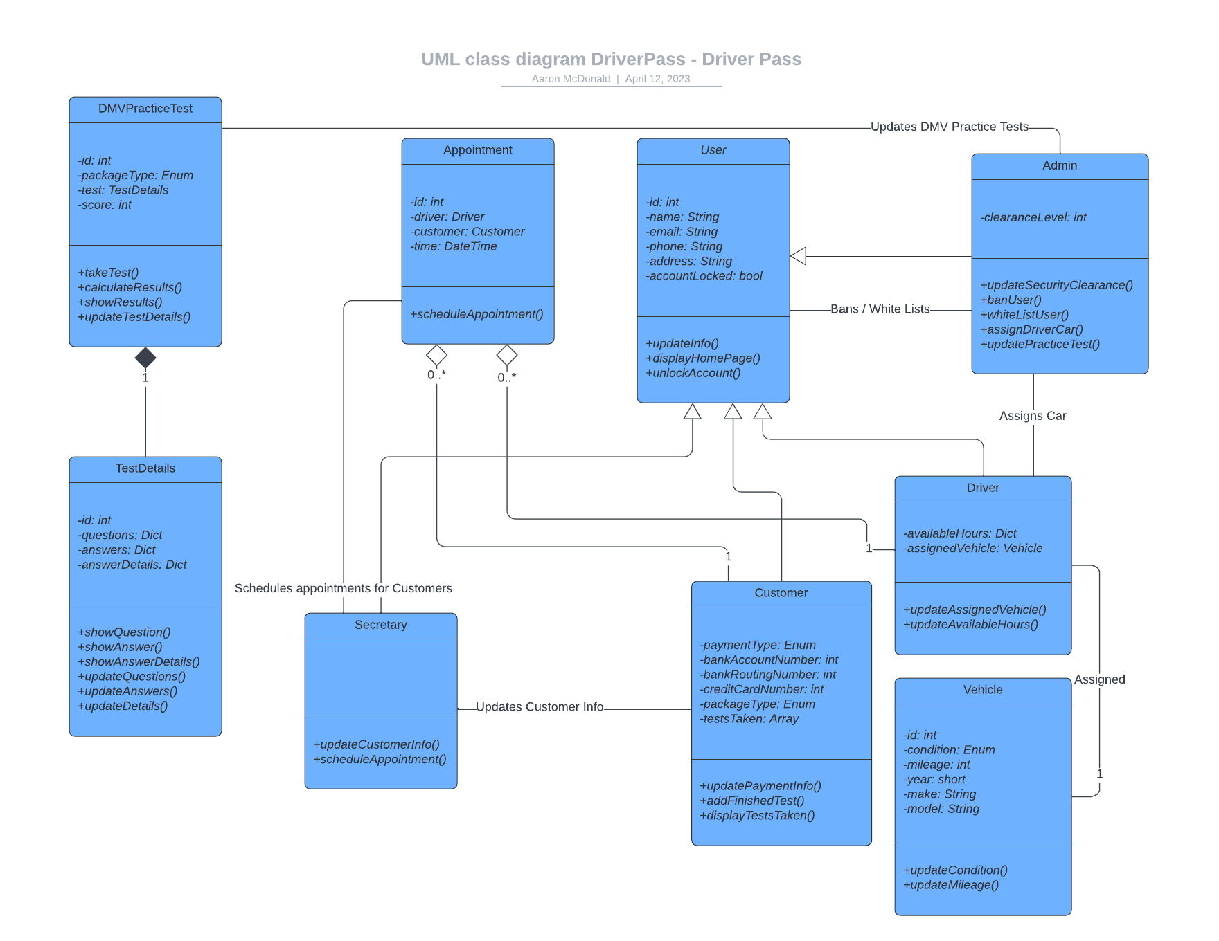

## Technical Requirements

For this system, I believe that the technical requirements heavily revolve around software for the system. Since DriverPass does not want to deal with the hardware of servers, this entire system will be dealt with over cloud computing, meaning that this will be entirely software based. That being said, I have laid out the software needs of at least two databases. The first database would be for storing the user information, while the second database is for storing the practice tests from DriverPass and storing any updates from the DMV. Additionally, this software will be web-based, meaning that this will entirely be a website, so the requirements for this will be to have a stand-alone website that allows for user interaction, updating user information and setting up appointments for customers.

The hardware that may be necessary for this system would be for the secretary. At the very least, the secretary will need their own computer to be able to submit information to the system on customers’ behalf. Additionally, company vehicles will be needed to assign to drivers and allow the on-the-road instruction to take place. Lastly, there will need to be some interaction with the DMV to establish regular updates for any changes that may occur from local DMV’s regarding practice tests and information to provide to users.